R&D dating for animal health and innovation
Marseille – 10/11 December 2019

The 5th edition of the “R&D dating for Animal Health and Innovation” business convention is hosted by BioFIT 2019. This event is organised by the French association for the animal healthcare Industry (SIMV).

Belen Barreiro (INGENASA) will give the vision of diagnostic companies to support the development of vaccines and ensure the success of good cooperation between the two industries.

“Which promises to be delivered by high potential vaccines?”

How can international and multidisciplinary approaches like the SAPHIR European project help develop innovative vaccination strategies? How are these kinds of projects integrating vaccination in a global health management system? What are the outcomes and expected developments in terms of vaccines production of these multi-million international project? How are these vaccines strengthening the profitability of food systems?

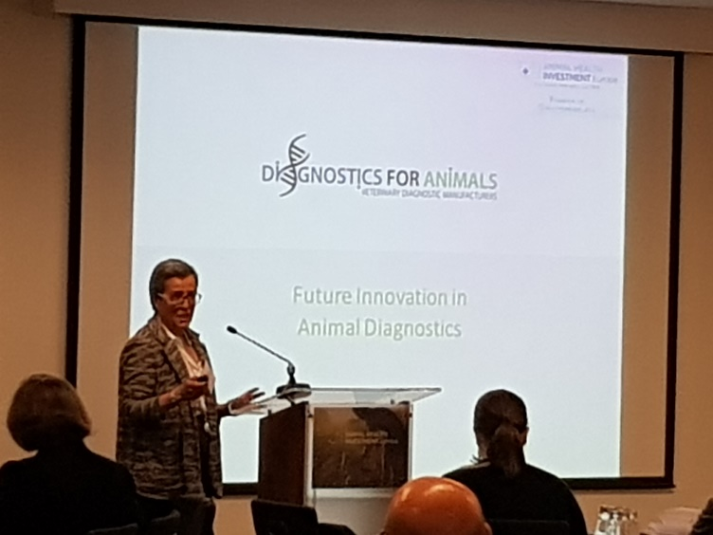

Please see the program >> here <<

