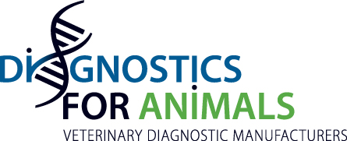

Press release

Diagnostics For Animals welcomes 3 new Members

Diagnostics For Animals is very pleased to announce that BIOMED DIAGNOSTICS, Southern Oregon, USA, DIATHEVA, Cartoceto, Italy and TETRACORE Rockville, USA, became members of the association during the last Board meeting hosted by Abingdon Health, UK, on October 17 2019.
For Jean-Louis Hunault:” The membership of these 3 companies based respectively in USA and Italy, reinforces the representativeness of our Federation. They all demonstrated to be in compliance with the highest standards of production of diagnostic kits and reagents in Animal Health ».

The Association has now 19 members producing and distributing more than 1700 different veterinary diagnostic tools.

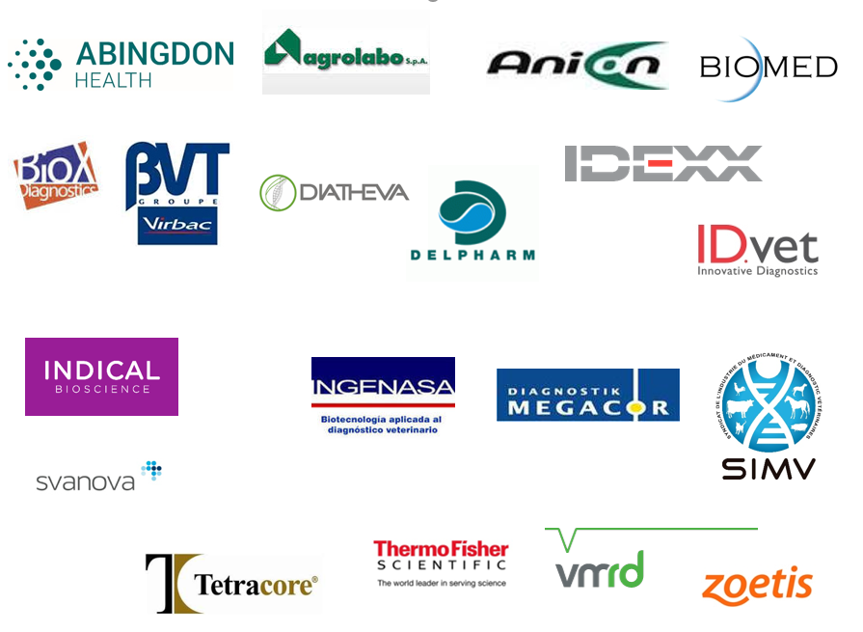

More information: http://diagnosticsforanimals.com/
Press contact: contact@diagnosticsforanimals.com

