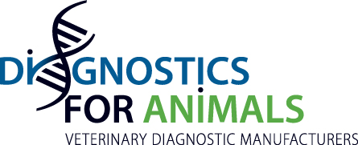

Press release

IABS MEETING MAY 15-17 2019 IN WIESBADEN, GERMANY

The last International Alliance for Biological Standardization meeting was held on May 15-17 in Wiesbaden, Germany.

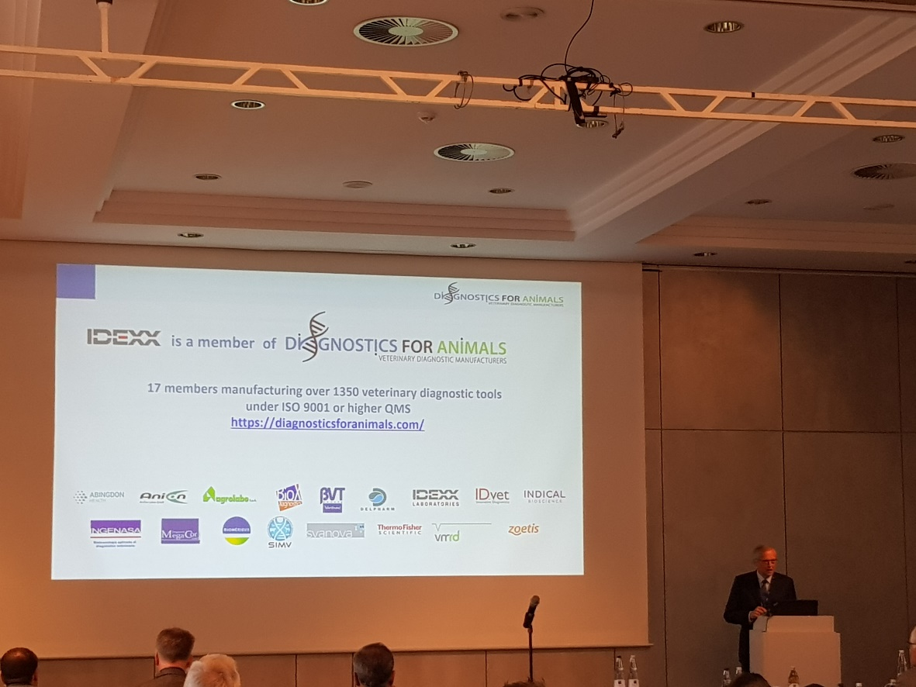
Serge Leterme, President of DiagnosticsForAnimals (D4A)

The topic of the meeting was “Diagnostics in the Veterinary Field: The Role in Health Surveillance and Disease Identification”.

Five of the seven D4A members attending the meeting were invited to talk about their experience on the field. Serge Leterme, President of D4A, gave a general overview of the technical and regulatory challenges when developing new tests.

His presentation is attached.

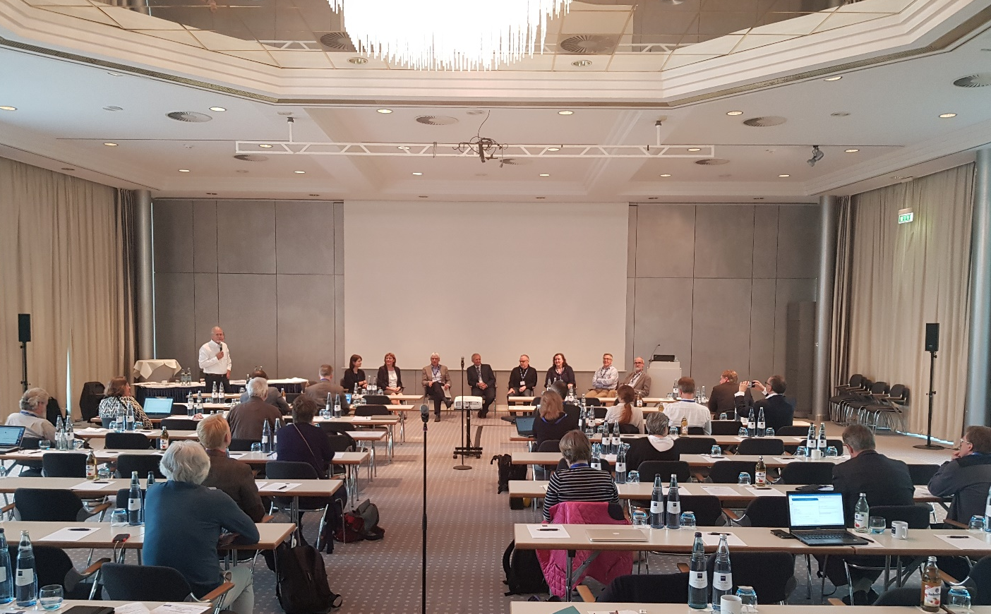

For Jean-Louis Hunault, Secretary General of D4A, "Our participation to the IABS meeting was in perfect alignment with D4A goals: harmonization of standards, coordination with authorities and agencies, promotion of innovation".

