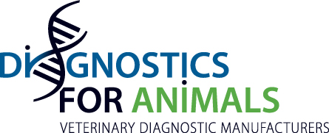

Press release

Health For Animals – Diagnostics For Animals Meeting

Diagnostics For Animals Chair (Serge Leterme) and General Secretary
(Jean-Louis Hunault) met Health For Animals Board on 28 March 2019 in Paris to identify the ways of a future collaboration.

The 2 Federations decided to stand their cooperation in the Regulatory area.

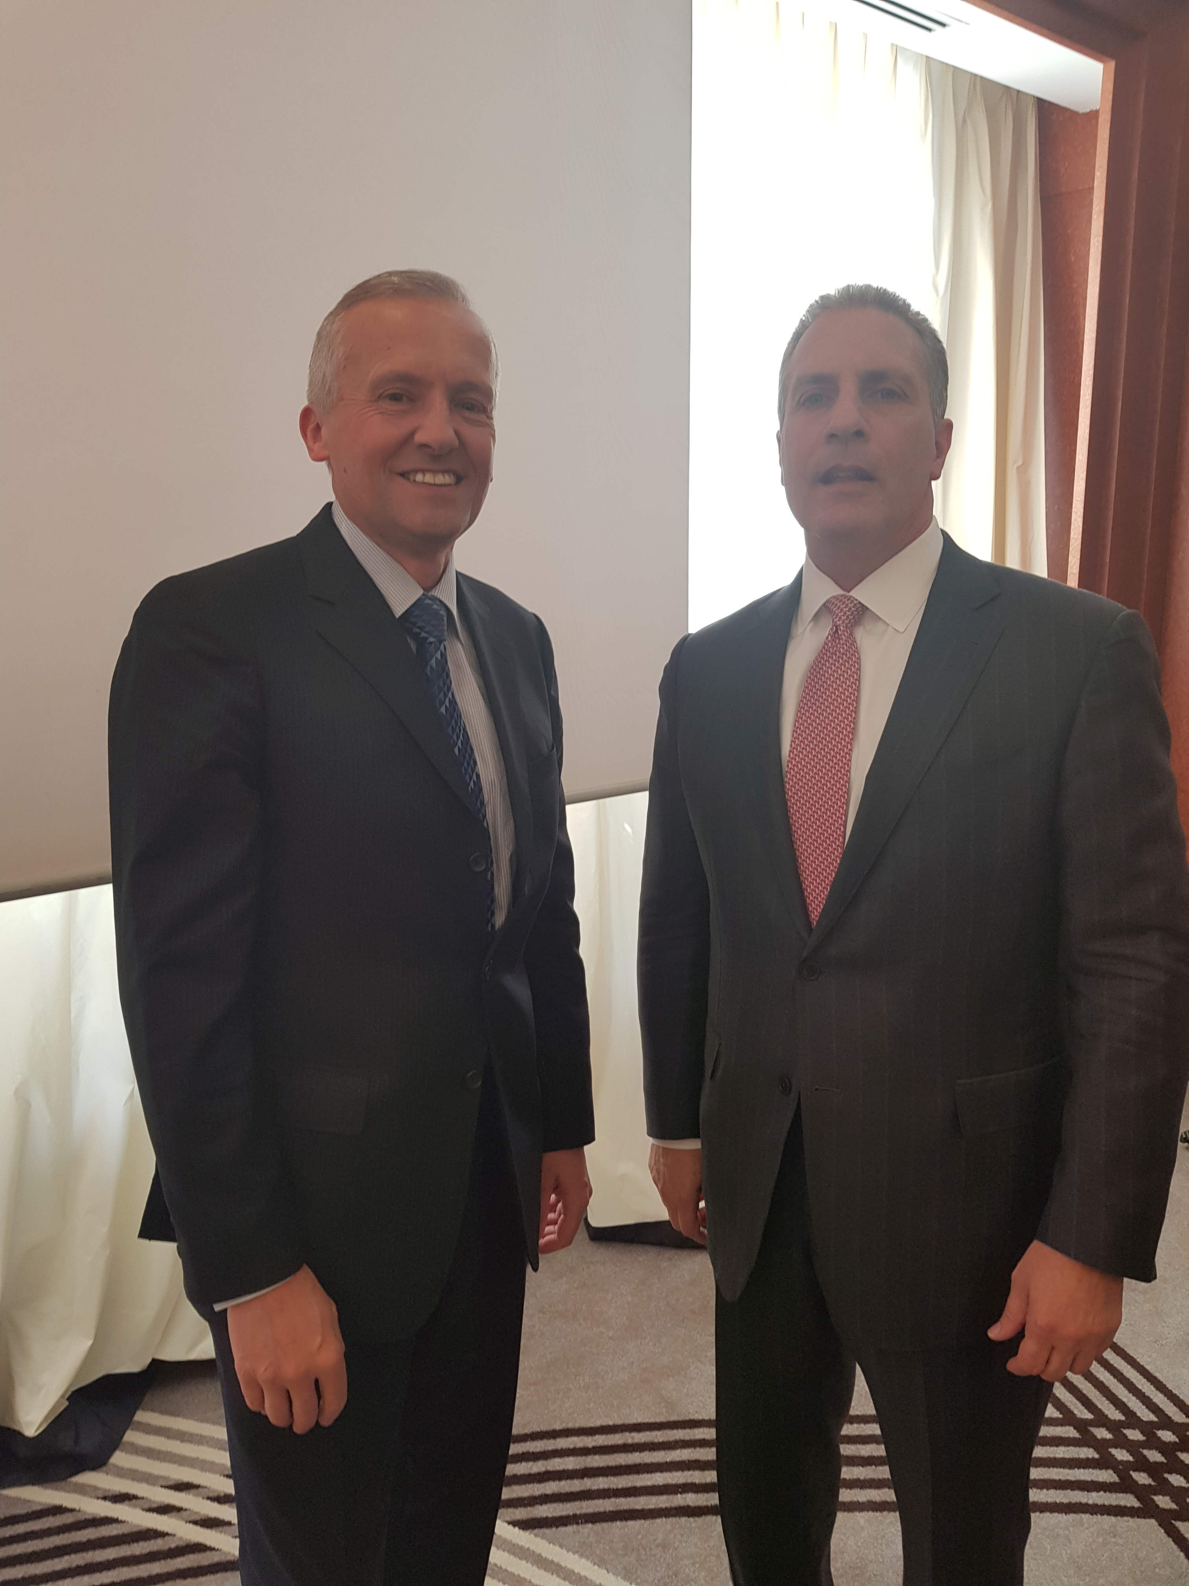

Serge Leterme (President of Diagnostics for Animals) – Richard De Luca (President of Health for Animals)

