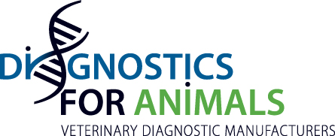

Press release

Diagnostics For Animals welcomes 3 new Members

During the last General Assembly which was held on 13 March 2019 in Bern at IDEXX Offices, 3 new Members joined Diagnostics For Animals :

- ABINGDON HEALTH Ltd Sand Hutton, York, YO41 1LZ UK
- ANICON Labor GmbH, Muehlenstraße 13, 49685 Hoeltinghausen Germany
- VMRD PO Box 502 Pullman, WA 99163 USA

For Jean-Louis Hunault:” The adhesion of these 3 new companies based respectively in UK, Germany and USA, and meeting the highest standards of production of Diagnostics in Animal Health, reinforces the representativeness of our Federation”.

The Association now has 17 members:

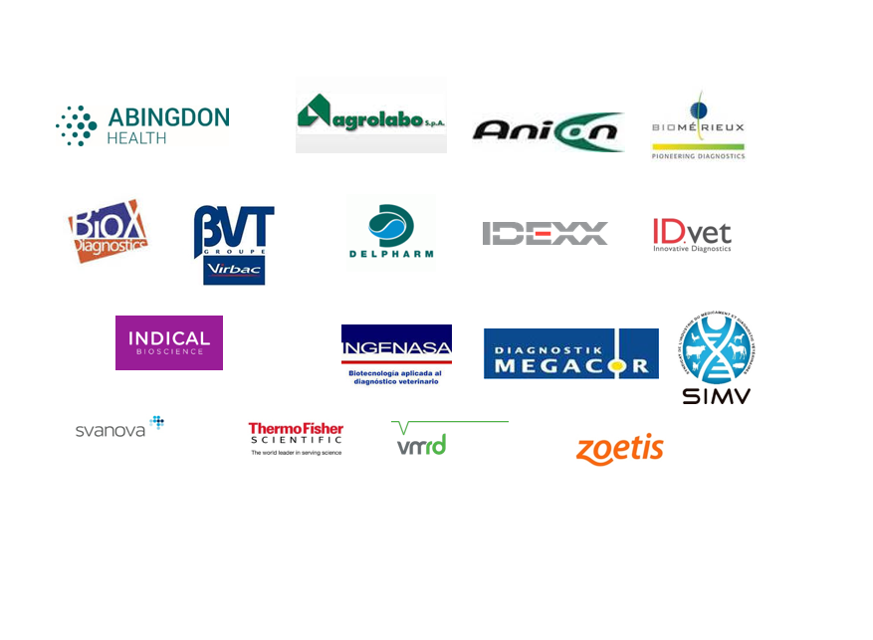

More information: http://diagnosticsforanimals.com/
Press contact: contact@diagnosticsforanimals.com

