Paris, 16th March

Press Release

The 13th Diagnostics for Animals General Assembly was held on March 16th, 2018, at Delpharm Offices in Lyon.
Serge Leterme was elected as new chair, replacing Johanna Koolen who is retiring from the Presidency of the Association after more than 10 years spent at that position.

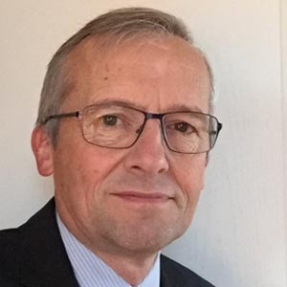
Serge Leterme says: “It is a real honor and pleasure for me to take over this responsibility, and work with all of our members on making Diagnostics for Animals recognized as a major contributing player and stakeholder in the “ONE Health” environment. We need to strengthen the role played by diagnostics tools in the today’s fight for a more responsible use of veterinary medicine, against the antimicrobial resistance (AMR) and to increase the productivity in livestock production.”
About DiagnosticsforAnimals:
Our missions:
- Federate and represent Manufacturers of Animal Health Diagnostics in Europe broadly (Condition of membership: ISO 9001 certified)
- Explain the benefit of a harmonized, efficient, and transparent regulatory framework to permit the AHDx to be in compliance with various Regulatory Requirements
- Promote initiatives for the development of Animal Health Diagnostics for emerging diseases
- Promote collaborations with other actors in Animal Health (institutes, vaccine producers, etc.)

Diagnostics For Animals 11, rue des messageries 75010 Paris Phone: + 33 1 53 34 43 43 diagnosticsforanimals.com/

