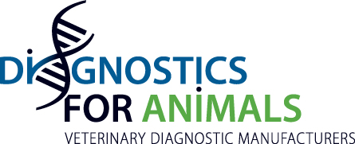

March 14th, 2017 in Montpellier

Press Release

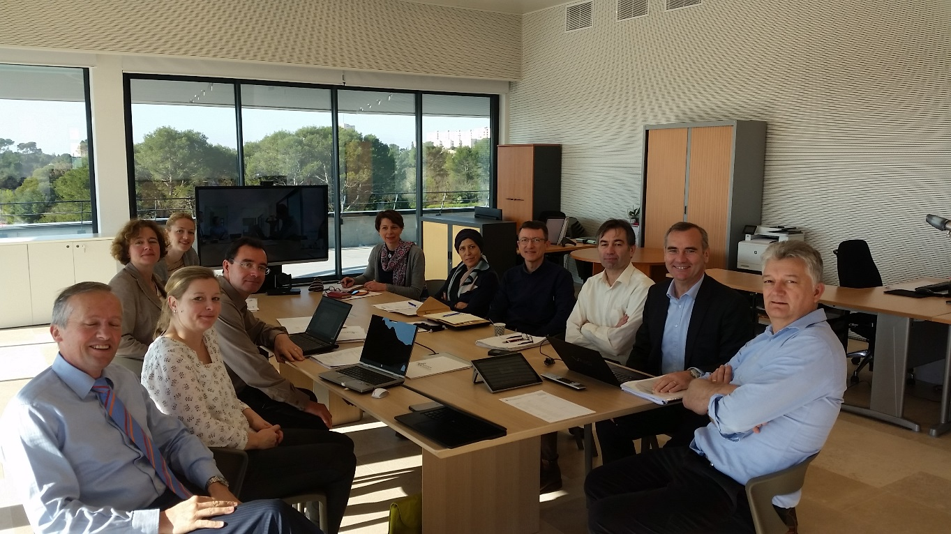

DIAGNOSTICSFORANIMALS has held its General assembly in Montpellier on the invitation of ID VET President Philippe Pourquier the 14th of March 2017.
The members of D4A agreed that the application of the regulations on biocides and Biodiversity on their sector is a priority, and expect the European Union to take a stand while taking veterinary diagnostics into account.
Additionally, members expressed the wish to work concretely on the promotion of an effective and pragmatic EU harmonization for the control of Veterinary In Vitro Diagnostics by means of close and constructive collaboration with major veterinary agencies, such as FLI and ANSES.

